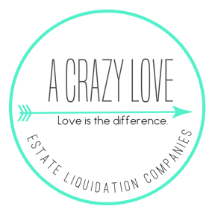
A Crazy Love’s Ashley Glass Luxury Estate Sales & The Vintage Girls
770-640-7433 sales@acrazylove.com www.acrazylove.com
SERVICES COMPARISON CHART
 | A Crazy Love Estate Liquidation Companies, LLC |  | Other Company
 | Locally Owned | ✔ | Locally Owned
 | How many sales conducted by you personally (not franchise as whole) | 1,100+ | How many sales conducted by you personally (not franchise as whole)
 | How Many Followers on Facebook? | 7,000+ | How Many Followers on Facebook?
 | Certified Appraiser on Staff | ✔ | Certified Appraiser on Staff
 | Staff of 21 (All W-2, No Subcontractors or Day Laborers) Avg 7 years at company | ✔ | Number on Staff (Any Subcontractors or Day Laborers)
 | Brick and Mortar Office | ✔ | Is your business run out of your home?
 | Current Business License | ✔ | Current Business License
 | Staff Covered by Workers Comp | ✔ | Staff Covered by Workers Comp
 | Million Dollar Liability Policy | ✔ | Million Dollar Liability Policy
 | Collects and Pays All Sales Tax | ✔ | Collects and Pays All Sales Tax
 | Minimum Staff of 4 at Every Sale, Up to 14 Luxury Sales/4 Cashiers | ✔ | How many staff will you have?
 | Provides Post Sales Inventory List | ✔ | Provides Post Sales Inventory List
 | Social Media Assistant on Staff | ✔ | Social Media Presence?
 | Features Sales on EstateSales.Net | ✔ | Features Sales on EstateSales.Net
 | Features Sales on EstateSales.Com | ✔ | Features Sales on EstateSales.Com
 | How many email subscribers? | Ask | How many email subscribers?
 | Posts All Sales to Craigslist | ✔ | Posts All Sales to Craigslist
 | Uses Facebook & Instagram Ads | ✔ | Uses Facebook & Instagram Ads
 | Places and Post Roadside Signs | ✔ | Places and Post Roadside Signs
 | Prices Every Item Individually in Home | ✔ | Prices Every Item Individually in Home
 | All 1,100+ Estate Sales Conducted Have Been Priced by Our Owner | ✔ | Who prices the items at your sale? What is their experience?
 | Funds Managed Via Escrow Account | ✔ | Funds Managed Via Escrow Account
 | Excellent Recent References | ✔ | Excellent Recent References
 | $7.68 Million Dollars in Gross Sales to Date | ✔ | Total of Gross Sales to Date

